**AMERICAN INTERNATIONAL**

**UNIVERSITY-BANGLADESH**

408/1, Kuratoli, Khilkhet, Dhaka 1229, Bangladesh

|  |  |  |
| --- | --- | --- |
| Assignment Title: **Data Comm Assignment 2** |  |  |
| Assignment No: **2** |  | Date of Submission: **07/04/2020** |
| Course Title: DATA COMMUNICATION |  |  |
| Course Code: **COE3103** |  | Section: **L** |
| Semester: **Spring** **(2019-2020)** |  | Course Teacher: **TANJIL AMIN** |

**Declaration and Statement of Authorship:**

1. I/we hold a copy of this Assignment/Case-Study, which can be produced if the original is lost/damaged.
2. This Assignment/Case-Study is my/our original work and no part of it has been copied from any other student’s work or from any other source except where due acknowledgement is made.
3. No part of this Assignment/Case-Study has been written for me/us by any other person except where such collaborationhas been authorized by the concerned teacher and is clearly acknowledged in the assignment.
4. I/we have not previously submitted or currently submitting this work for any other course/unit.
5. This work may be reproduced, communicated, compared and archived for the purpose of detecting plagiarism.
6. I/we give permission for a copy of my/our marked work to be retained by the Faculty for review and comparison, including review by external examiners.
7. I/we understand that Plagiarism is the presentation of the work, idea or creation of another person as though it is your own. It is a formofcheatingandisaveryseriousacademicoffencethatmayleadtoexpulsionfromtheUniversity. Plagiarized material can be drawn from, and presented in, written, graphic and visual form, including electronic data, and oral presentations. Plagiarism occurs when the origin of them arterial used is not appropriately cited.
8. I/we also understand that enabling plagiarism is the act of assisting or allowing another person to plagiarize or to copy my/our work.

*\* Student (s) must complete all details except the faculty use part.*

** Please submit all assignments to your course teacher or the office of the concerned teacher.

Group Name

/

No.

:

6

|  |  |  |  |  |
| --- | --- | --- | --- | --- |
| **No** | **Name** | **ID** | **Program** | **Signature** |
| 1 | **JOY KARMOKAR** | **18-39263-3** | **BSc CSE** | *Joy- 07/04/2020* |

|  |  |  |
| --- | --- | --- |
| ***Faculty use only*** |  | |
| FACULTY COMMENTS: | **Marks Obtained** |  |
|  |
|  |
|  | **Total Marks** |  |
|  |
|  |

**CHAPTER-5 ANALOG TRANSMISSION**

**5.4.3 Problems**

**P5-1.Q. Calculate the baud rate for the given bit rate and type of modulation.**

1. **2000 bps, FSK**
2. **4000 bps, ASK**
3. **6000 bps, QPSK**
4. **36,000 bps, 64-QAM**

**ANSWER:**

We use the formula S = (1/r) ´ N, but first we need to calculate the value of r for each case.

|  |  |  |  |  |
| --- | --- | --- | --- | --- |
| a. r = log22 | = 1 | → | S = (1/1) ´ (2000 bps) | = 2000 baud |
| b. r = log22 | = 1 | → | S = (1/1) ´ (4000 bps) | = 4000 baud |
| c. r = log24 | = 2 | → | S = (1/2) ´ (6000 bps) | = 3000 baud |
| d. r = log264 | = 6 | → | S = (1/6) ´ (36,000 bps) | = 6000 baud |

**P5-2.Q. Calculate the bit rate for the given baud rate and type of modulation.**

1. **1000 baud, FSK**
2. **1000 baud, ASK**
3. **1000 baud, BPSK**
4. **1000 baud, 16-QAM**

**ANSWER:**

We use the formula N = r ´ S, but first we need to calculate the value of r for each case.

|  |  |  |  |  |
| --- | --- | --- | --- | --- |
| a. r = log22 | = 1 | → | N = (1) ´ (1000 bps) | = 1000 bps |
| b. r = log22 | = 1 | → | N = (1) ´ (1000 bps) | = 1000 bps |
| c. r = log22 | = 1 | → | N = (1) ´ (1000 bps) | = 1000 bps |
| d. r = log216 | = 4 | → | N = (4) ´ (1000 bps) | = 4000 bps |

**P5-3.Q. What is the number of bits per baud for the following techniques?**

1. **ASK with four different amplitudes**
2. **FSK with eight different frequencies**
3. **PSK with four different phases**
4. **QAM with a constellation of 128 points**

**ANSWER:**

We use the formula r = log2L to calculate the value of r for each case.

* 1. log24 = 2
  2. log28 = 3
  3. log24 = 2

d. log2128 = 7

**P5-4.Q. Draw the constellation diagram for the following:**

1. **ASK, with peak amplitude values of 1 and 3**
2. **BPSK, with a peak amplitude value of 2**
3. **QPSK, with a peak amplitude value of 3**
4. **8-QAM with two different peak amplitude values, 1 and 3, and four different phases**

**ANSWER:**

1. We have two signal elements with peak amplitudes 1 and 3. The phase of both signal elements are the same, which we assume to be 0 degrees.
2. We have two signal elements with the same peak amplitude of 2. However, there must be 180 degrees difference between the two phases. We assume one phase to be 0 and the other 180 degrees.
3. We have four signal elements with the same peak amplitude of 3. However, there must be 90 degrees difference between each phase. We assume the first phase to be at 45, the second at 135, the third at 225, and the fourth at 315 degrees. Note that this is one out of many configurations. The phases can be at 0, 90, 180, and 270. As long as the differences are 90 degrees, the solution is satisfactory.
4. We have four phases, which we select to be the same as the previous case. For each phase, however, we have two amplitudes, 1 and 3 as shown in the figure. Note that this is one out of many configurations. The phases can be at 0, 90, 180, and 270. As long as the differences are 90 degrees, the solution is satisfice.

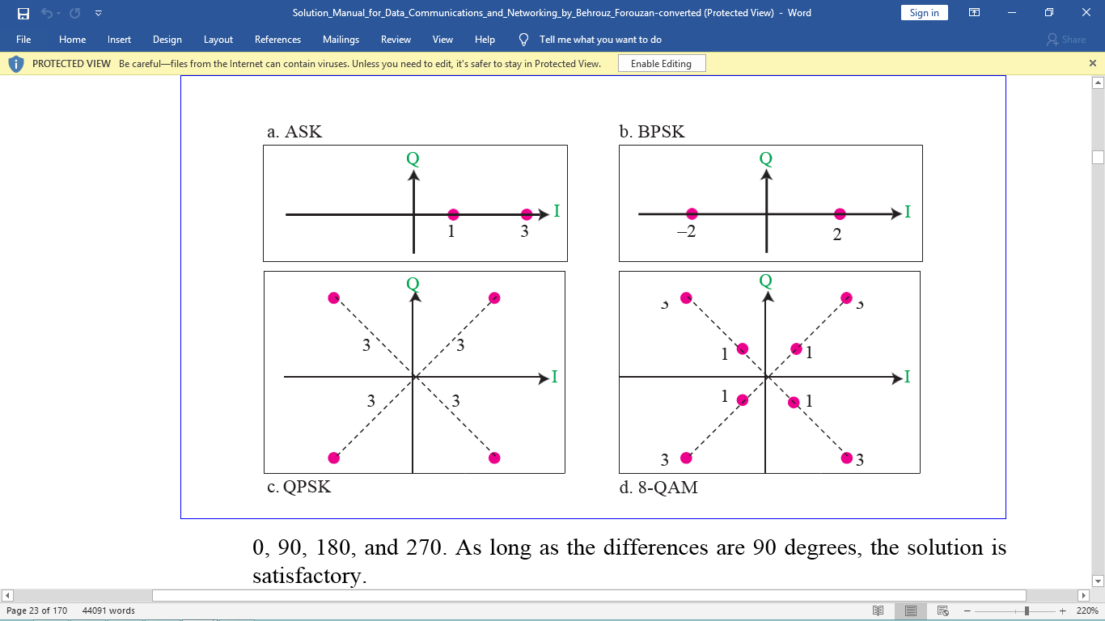

**P5-5. Q. Draw the constellation diagram for the following cases. Find the peak amplitude value for each case and define the type of modulation (ASK, FSK, PSK, or QAM).The numbers in parentheses define the values of I and Q respectively.**

1. **Two points at (2, 0) and (3, 0)**
2. **Two points at (3, 0) and (−3, 0)**
3. **Four points at (2, 2), (−2, 2), (−2, −2), and (2, −2)**
4. **Two points at (0, 2) and (0, −2)**

**ANSWER:**

a. This is ASK. There are two peak amplitudes both with the same phase (0 degrees). The values of the peak amplitudes are A1 = 2 (the distance between the first dot and the origin) and A2= 3 (the distance between the second dot and the origin).

1. This is BPSK, There is only one peak amplitude (3). The distance between each dot and the origin is 3. However, we have two phases, 0 and 180 degrees.
2. This can be either QPSK (one amplitude, four phases) or 4-QAM (one amplitude and four phases). The amplitude is the distance between a point and the origin, which is (22 + 22)1/2 = 2.83.
3. This is also BPSK. The peak amplitude is 2, but this time the phases are 90 and 270 degrees.

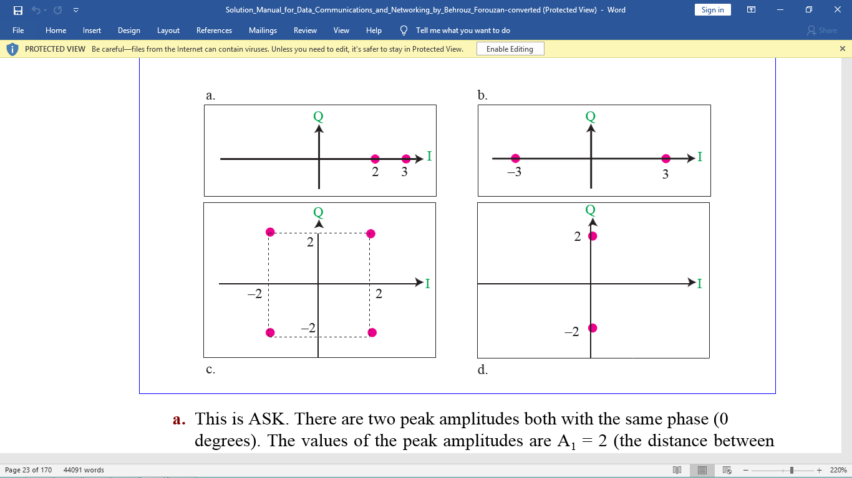

**P5-6.Q. How many bits per baud can we send in each of the following cases if the signal constellation has one of the following number of points?**

1. **2**
2. **4**
3. **16**
4. **1024**

**ANSWER:**

The number of points define the number of levels, L. The number of bits per baud is the value of r. Therefore, we use the formula r = log2L for each case.

1. log22 = 1
2. log24 = 2
3. log216 = 4
4. d. log21024 = 10

**P5-7.Q. What is the required bandwidth for the following cases if we need to send 4000 bps? Let d = 1.**

1. **ASK**
2. **FSK with 2∆f = 4 KHz**
3. **QPSK**
4. **16-QAM**

**ANSWER:**

We use the formula B = (1 + d) ´ (1/r) ´ N, but first we need to calculate the value of r for each case.

|  |  |  |  |
| --- | --- | --- | --- |
| a. r = 1 | ® | B= (1 + 1) ´ (1/1) ´ (4000 bps) | = 8000 Hz |
| b. r = 1 | ® | B = (1 + 1) ´ (1/1) ´ (4000 bps) + 4 KHz | = 8000 Hz |
| c. r = 2 | ® | B = (1 + 1) ´ (1/2) ´ (4000 bps) | = 2000 Hz |
| d. r = 4 | ® | B = (1 + 1) ´ (1/4) ´ (4000 bps) | = 1000 Hz |
|  |  |  |  |

**P5-8.Q. The telephone line has 4 KHz bandwidth. What is the maximum number of bits we can send using each of the following techniques? Let d = 0.**

1. **ASK**
2. **QPSK**
3. **16-QAM**
4. **64-QAM**

**ANSWER:**

We use the formula N = [1/(1 + d)] ´ r ´ B, but first we need to calculate the value of r for each case.

|  |  |  |  |
| --- | --- | --- | --- |
| a. r = log22 = 1 | ® | N= [1/(1 + 0)] ´ 1 ´ (4 KHz) | = 4 kbps |
| b. r = log24=2 | ® | N = [1/(1 + 0)] ´ 2 ´ (4 KHz) | = 8 kbps |
| c. r = log216= 4 | ® | N = [1/(1 + 0)] ´ 4 ´ (4 KHz) | = 16 kbps |
| d. r = log264= 6 | ® | N = [1/(1 + 0)] ´ 6 ´ (4 KHz) | = 24 kbps |

**P5-9. Q. A corporation has a medium with a 1-MHz bandwidth (low pass). The corporation needs to create 10 separate independent channels each capable of sending at least 10 Mbps. The company has decided to use QAM technology. What is the minimum number of bits per baud for each channel? What is the number of points in the constellation diagram for each channel? Let d = 0.**

**ANSWER:**

First, we calculate the bandwidth for each channel = (1 MHz) / 10 = 100 KHz. We then find the value of r for each channel:

B = (1 + d) ´ (1/r) ´ (N) ® r = N / B ® r = (1 Mbps/100 KHz) = 10

We can then calculate the number of levels: L = 2r = 210 = 1024. This means that that we need a 1024-QAM technique to achieve this data rate.

**P5-10.Q. A cable company uses one of the cable TV channels (with a bandwidth of 6 MHz) to provide digital communication for each resident. What is the available data rate for each resident if the company uses a 64-QAM technique?**

**ANSWER:**

We can use the formula: N = [1/(1 + d)] ´ r ´ B = 1 ´ 6 ´ 6 MHz = 36 Mbps

**P5-11.Q. Find the bandwidth for the following situations if we need to modulate a 5-KHz voice.**

1. **AM**
2. **FM (β = 5)**
3. **PM (β = 1)**

**ANSWER:**

1. BAM = 2 ´ B = 2 ´ 5= 10 KHz
2. BFM = 2 ´ (1 + b) ´ B = 2 ´ (1 + 5) ´ 5= 60 KHz
3. BPM = 2 ´ (1 + b) ´ B = 2 ´ (1 + 1) ´ 5= 20 KHz

**P5-12.Q. Find the total number of channels in the corresponding band allocated by FCC.**

1. **AM**
2. **FM**

**ANSWER:**

We calculate the number of channels, not the number of coexisting stations.

1. n = (1700 - 530) KHz / 10 KHz= 117
2. n = (108 - 88) MHz / 200 KHz= 100

**6.4.3 Problems**

**P6-1.Q. Assume that a voice channel occupies a bandwidth of 4 kHz. We need to multiplex 10 voice channels with guard bands of 500 Hz using FDM. Calculate the required bandwidth.**

**ANSWER:**

To multiplex 10 voice channels, we need nine guard bands. The required band- width is then B = (4 KHz) ´ 10 + (500 Hz) ´ 9 = 44.5 KHz

**P6-2.Q. we need to transmit 100 digitized voice channels using a passband channel of 20 KHz. What should be the ratio of bits/Hz if we use no guard band?**

**ANSWER:**

The bandwidth allocated to each voice channel is 20 KHz / 100 = 200 Hz. As we saw in the previous chapters, each digitized voice channel has a data rate of 64 Kbps (8000 sample ´ 8 bit/sample). This means that our modulation technique uses 64,000/200 = 320 bits/Hz

**P6-3.Q. In the analog hierarchy of Figure 6.9, find the overhead (extra bandwidth for guard band or control) in each hierarchy level (group, super group, master group, and jumbo group).**

**ANSWER:**

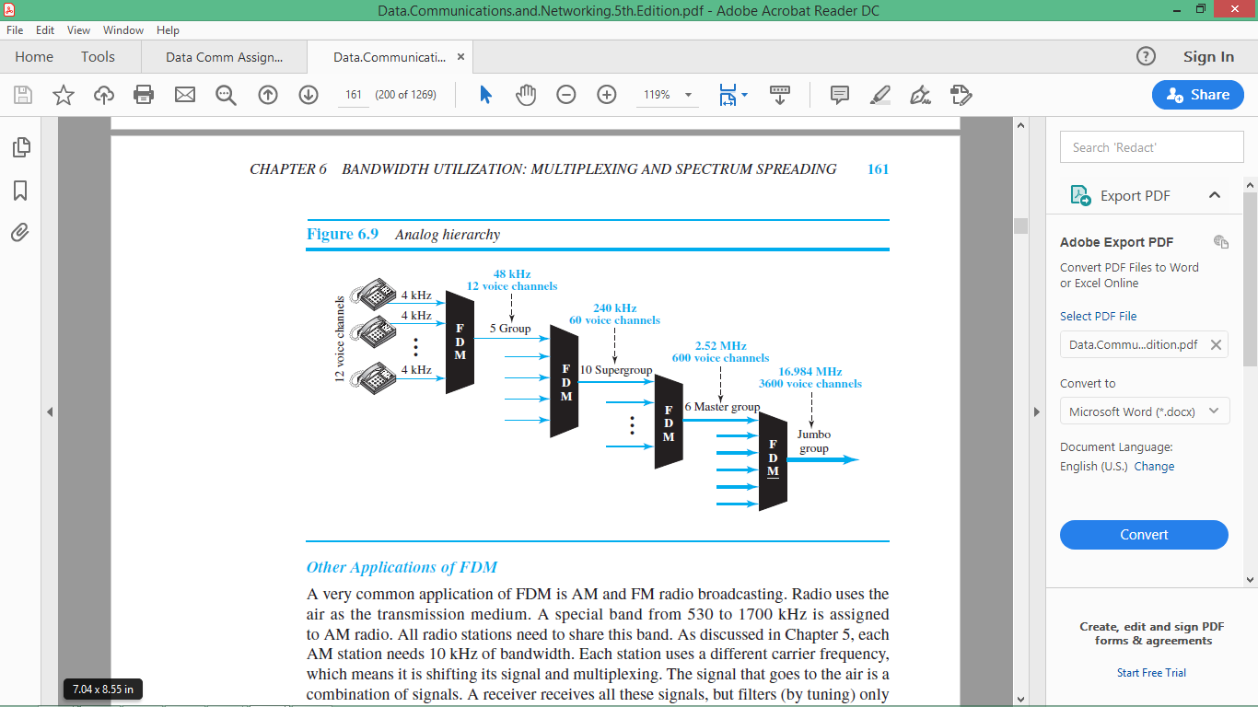

1. Group level: overhead = 48 KHz - (12 ´ 4 KHz) = 0 Hz.
2. Super group level: overhead = 240 KHz - (5 ´ 48 KHz) = 0 Hz.
3. Master group: overhead = 2520 KHz - (10 ´ 240 KHz) = 120 KHz.
4. Jumbo Group: overhead = 16.984 MHz - (6 ´ 2.52 MHz) = 1.864 MHz.

**P6-4.Q. We need to use synchronous TDM and combine 20 digital sources, each of 100Kbps. Each output slot carries 1 bit from each digital source, but one extra bit is added to each frame for synchronization. Answer the following questions:**

1. **What is the size of an output frame in bits?**
2. **What is the output frame rate?**
3. **What is the duration of an output frame?**
4. **What is the output data rate?**
5. **What is the efficiency of the system (ratio of useful bits to the total bits)?**

**ANSWER:**

1. Each output frame carries 1 bit from each source plus one extra bit for synchro- nization. Frame size = 20 ´ 1 + 1 = 21 bits.
2. Each frame carries 1 bit from each source. Frame rate = 100,000 frames/s.
3. Frame duration = 1 /(frame rate) = 1 /100,000 = 10 ms.
4. Data rate = (100,000 frames/s) ´ (21 bits/frame) = 2.1 Mbps
5. In each frame 20 bits out of 21 are useful. Efficiency = 20/21= 95%

**P6-5.Q. Repeat Problem 6-4 if each output slot carries 2 bits from each source.**

**ANSWER:**

1. Each output frame carries 2 bits from each source plus one extra bit for syn- chronization. Frame size = 20 ´ 2 + 1 = 41 bits.
2. Each frame carries 2 bit from each source. Frame rate = 100,000/2 = 50,000 frames/s.
3. Frame duration = 1 /(frame rate) = 1 /50,000 = 20 ms.
4. Data rate = (50,000 frames/s) ´ (41 bits/frame) = 2.05 Mbps. The output data rate here is slightly less than the one in Exercise 16.
5. In each frame 40 bits out of 41 are useful. Efficiency = 40/41= 97.5%. Effi- ciency is better than the one in Exercise 16.

**P6-6. Q.We have 14 sources, each creating 500 8-bit characters per second. Since only some of these sources are active at any moment, we use statistical TDM to combine these sources using character interleaving. Each frame carries 6 slots at a time, but we need to add 4-bit addresses to each slot. Answer the following questions:**

1. **What is the size of an output frame in bits?**
2. **What is the output frame rate?**
3. **What is the duration of an output frame?**
4. **What is the output data rate?**

**ANSWER:**

1. Frame size = 6 ´ (8 + 4) = 72 bits.
2. We can assume that we have only 6 input lines. Each frame needs to carry one character from each of these lines. This means that the frame rate is 500 frames/s.
3. Frame duration = 1 /(frame rate) = 1 /500 = 2 ms.
4. Data rate = (500 frames/s) ´ (72 bits/frame) = 36 kbps.

**P6-7.Q. Ten sources, six with a bit rate of 200 kbps and four with a bit rate of 400 kbps, are to be combined using multilevel TDM with no synchronizing bits. Answer the following questions about the final stage of the multiplexing:**

1. **What is the size of a frame in bits?**
2. **What is the frame rate?**
3. **What is the duration of a frame?**
4. **What is the data rate?**

**ANSWER:**

We combine six 200-kbps sources into three 400-kbps. Now we have seven 400- kbps channel.

1. Each output frame carries 1 bit from each of the seven 400-kbps line. Frame size = 7 ´ 1 = 7 bits.
2. Each frame carries 1 bit from each 400-kbps source. Frame rate = 400,000 frames/s.
3. Frame duration = 1 /(frame rate) = 1 /400,000 = 2.5 ms.
4. Output data rate = (400,000 frames/s) ´ (7 bits/frame) = 2.8 Mbps. We can also calculate the output data rate as the sum of input data rate because there is no synchronizing bits. Output data rate = 6 ´ 200 + 4 ´ 400 = 2.8 Mbps.

**CHAPTER 6 - BANDWIDTH UTILIZATION: MULTIPLEXING AND SPECTRUM SPREADING**

**P6-8.Q. Four channels, two with a bit rate of 200 kbps and two with a bit rate of 150 kbps, are to be multiplexed using multiple-slot TDM with no synchronization bits. Answer the following questions:**

1. **What is the size of a frame in bits?**
2. **What is the frame rate?**
3. **What is the duration of a frame?**
4. **What is the data rate?**

**ANSWER:**

1. The frame carries 4 bits from each of the first two sources and 3 bits from each of the second two sources. Frame size = 4 ´ 2 + 3 ´ 2 = 14 bits.
2. Each frame carries 4 bit from each 200-kbps source or 3 bits from each 150 kbps. Frame rate = 200,000 / 4 = 150,000 /3 = 50,000 frames/s.
3. Frame duration = 1 /(frame rate) = 1 /50,000 = 20 ms.
4. Output data rate = (50,000 frames/s) ´ (14 bits/frame) = 700 kbps. We can also calculate the output data rate as the sum of input data rates because there are no synchronization bits. Output data rate = 2 ´ 200 + 2 ´ 150 = 700 kbps.

**P6-9. Two channels, one with a bit rate of 190 kbps and another with a bit rate of 180 kbps, are to be multiplexed using pulse-stuffing TDM with no synchronization bits. Answer the following questions:**

* 1. **What is the size of a frame in bits?**
  2. **What is the frame rate?**
  3. **What is the duration of a frame?**
  4. **What is the data rate?**

**ANSWER:**

We need to add extra bits to the second source to make both rates = 190 kbps. Now we have two sources, each of 190 Kbps.

1. The frame carries 1 bit from each source. Frame size = 1 + 1 = 2 bits.
2. Each frame carries 1 bit from each 190-kbps source. Frame rate = 190,000 frames/s.
3. Frame duration = 1 /(frame rate) = 1 /190,000 = 5.3 ms.
4. Output data rate = (190,000 frames/s) ´ (2 bits/frame) = 380 kbps. Here the output bit rate is greater than the sum of the input rates (370 kbps) because of extra bits added to the second source.

**P6-10.Q. Answer the following questions about a T-1 line:**

1. **What is the duration of a frame?**
2. **What is the overhead (number of extra bits per second)?**

**ANSWER:**

1. T-1 line sends 8000 frames/s. Frame duration = 1/8000 = 125 ms.
2. Each frame carries one extra bit. Overhead = 8000 ´ 1 = 8 kbps

**P6-11.Q. Show the contents of the five output frames for a synchronous TDM multiplexer that combines four sources sending the following characters. Note that the characters are sent in the same order that they are typed. The third source is silent.**

1. **Source 1 message: HELLO**
2. **Source 2 message: HI**
3. **Source 3 message:**
4. **Source 4 message: BYE**

**ANSWER:**

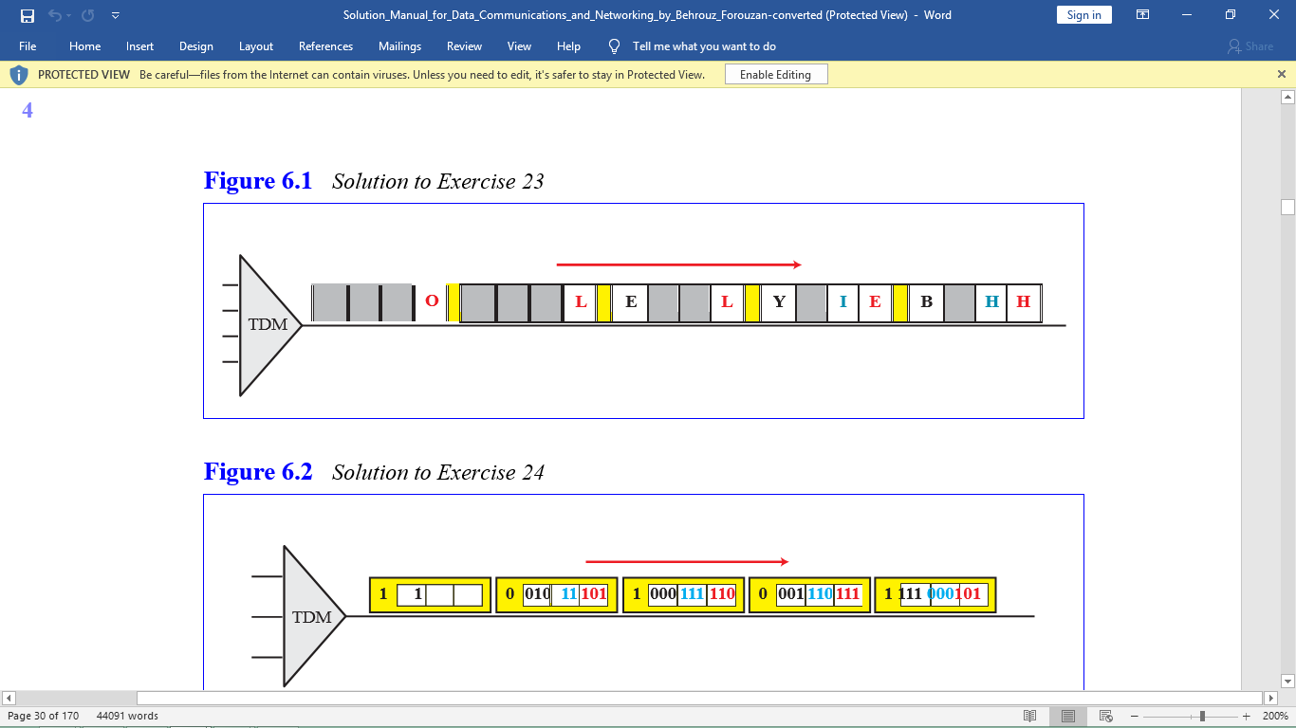

**P6-12. Q.Figure 6.34 shows a multiplexer in a synchronous TDM system. Each output slot is only 10 bits long (3 bits taken from each input plus 1 framing bit). What is the output stream? The bits arrive at the multiplexer as shown by the arrows.**

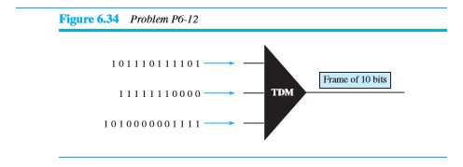

**ANSWER:** 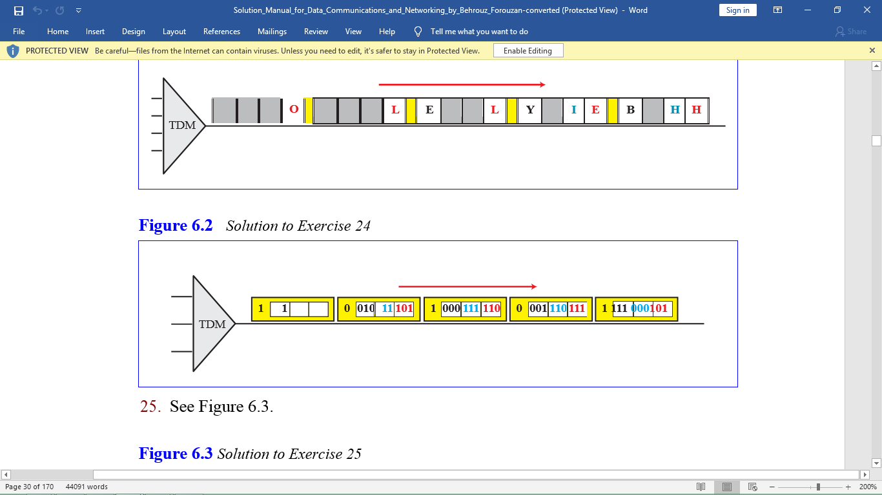

**P6-13. Q.Figure 6.35 shows a demultiplexer in a synchronous TDM. If the input slot is 16 bits long (no framing bits), what is the bit stream in each output? The bits arrive at the demultiplexer as shown by the arrows.**

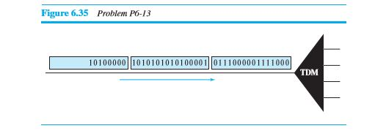

**ANSWER:**



**P6-14. Q. Answer the following questions about the digital hierarchy in Figure 6.23:**

* 1. **What is the overhead (number of extra bits) in the DS-1 service?**
  2. **What is the overhead (number of extra bits) in the DS-2 service?**
  3. **What is the overhead (number of extra bits) in the DS-3 service?**
  4. **What is the overhead (number of extra bits) in the DS-4 service?**

**ANSWER:**

1. DS-1 overhead = 1.544 Mbps - (24 x 64 kbps) = 8 kbps.
2. DS-2 overhead = 6.312 Mbps - (4 x 1.544 Mbps) = 136 kbps.
3. DS-3 overhead = 44.376 Mbps - (7 x 6.312 Mbps) = 192 kbps.
4. DS-4 overhead = 274.176 Mbps - (6 x 44.376 Mbps) = 7.92 Mbps.